Chapter 1

Introduction to the Study

In today’s digital age, businesses increasingly rely on online marketing strategies to attract, engage, and retain customers. Digital marketing has become an essential tool for promoting products, increasing brand visibility, and influencing consumer behavior. For small and medium enterprises (SMEs), the adoption of digital marketing is particularly critical, as it enables them to compete with larger brands by reaching wider audiences and building stronger customer relationships at relatively lower costs.
One such SME is LuvByTen, a brand specializing in ready-to-wear (RTW) clothing and baby essentials. As a growing business, LuvByTen leverages digital marketing to expand its market presence and boost sales. Social media platforms such as Facebook, Instagram, and TikTok provide opportunities for the brand to showcase products, run promotional campaigns, and interact directly with customers. These platforms not only facilitate product discovery but also influence consumer trust and decision-making by offering reviews, recommendations, and interactive engagement.
This study, titled “The Effectiveness of Digital Marketing on Customer Purchase Decisions,” aims to examine how digital marketing tools—specifically social media promotions, online advertisements, and e-commerce strategies—affect consumer behavior and buying intent. Using LuvByTen’s single-seller e-commerce platform as a case study, the research explores the relationship between digital marketing integration and consumer purchase decisions.
By analyzing customer perceptions of product presentation, promotional offers, and user feedback, the study seeks to understand how digital marketing shapes consumer trust, engagement, and purchasing behavior. The findings are expected to provide practical insights for SMEs, demonstrating how effective digital marketing strategies can enhance customer satisfaction, strengthen brand loyalty, and support business growth in the competitive online marketplace.

Background of the Study

The rise of digital technologies has reshaped the global business landscape, particularly in the field of marketing. Traditional marketing methods have gradually been supplemented—or even replaced—by digital strategies that leverage online platforms to reach, engage, and influence consumers. Digital marketing encompasses a wide range of tools, including social media promotions, search engine optimization, online advertisements, and e-commerce integrations, all of which aim to enhance brand visibility and drive consumer purchase decisions.

Numerous studies have highlighted the effectiveness of digital marketing in shaping consumer behavior. Research shows that factors such as product presentation, promotional discounts, and customer reviews significantly influence purchase intent in online shopping environments. Social media platforms like Facebook, Instagram, and TikTok have become central to this transformation, offering businesses opportunities to interact directly with customers, build trust, and foster long-term engagement.

For small and medium enterprises (SMEs), digital marketing provides a cost-effective means of competing with larger brands. By integrating marketing tools into e-commerce platforms, SMEs can create personalized shopping experiences, strengthen customer relationships, and expand their market reach. However, despite the growing importance of digital marketing, many SMEs face challenges in fully utilizing these strategies due to limited resources, technical expertise, and lack of research tailored to their specific contexts.

This study focuses on LuvByTen, a brand specializing in ready-to-wear (RTW) clothing and baby essentials, as a case study to examine the effectiveness of digital marketing on customer purchase decisions. By analyzing how digital marketing strategies influence consumer trust, engagement, and buying behavior within a single-seller e-commerce platform, the research aims to contribute to the broader understanding of how SMEs can leverage digital tools to thrive in the competitive online marketplace.

Statement of the Problem

The rapid growth of digital marketing has transformed the way businesses interact with consumers, particularly in the e-commerce sector. Social media platforms, online advertisements, and integrated ordering systems have become powerful tools for influencing consumer perceptions and purchase decisions. While large corporations have successfully leveraged these strategies, small and medium enterprises (SMEs) often face challenges in adopting and maximizing digital marketing due to limited resources, technical expertise, and market visibility.

For SMEs such as LuvByTen, which specializes in ready-to-wear (RTW) clothing and baby essentials, establishing a strong online presence is essential to remain competitive in today’s digital marketplace. However, there is limited research that specifically examines how digital marketing strategies affect consumer trust, engagement, and purchase intent in the context of single-seller e-commerce platforms.

This gap raises important questions:

- Which digital marketing tools most effectively influence consumer purchase decisions?

- How do product presentation, promotional campaigns, and customer feedback contribute to building trust and motivating purchases?

- To what extent does an integrated e-commerce system enhance customer satisfaction and encourage repeat buying behavior?

Addressing these questions is crucial for SMEs seeking to optimize their digital marketing strategies and expand their market reach. This study therefore investigates the effectiveness of digital marketing in shaping consumer purchase decisions, using LuvByTen’s e-commerce platform as a case study.

Objective of the Study

The primary objective of this study is to examine the effectiveness of digital marketing strategies in influencing customer purchase decisions within the context of a single-seller e-commerce platform. Specifically, the research focuses on LuvByTen, a brand specializing in ready-to-wear (RTW) clothing and baby essentials, to understand how digital marketing tools shape consumer trust, engagement, and buying behavior.

Specific Objectives:
1. To identify the digital marketing tools (e.g., social media promotions, online advertisements, and customer reviews) that most significantly influence consumer purchase intent.

2. To evaluate the usability and functionality of LuvByTen’s e-commerce platform, particularly its ordering and checkout processes, in relation to customer satisfaction.

3. To analyze the role of product presentation, promotional campaigns, and customer feedback in shaping consumer perceptions and motivating purchase decisions.

4. To determine how digital marketing strategies contribute to building consumer trust and engagement in an online shopping environment.

5. To provide practical insights and recommendations for SMEs on how to effectively integrate digital marketing into e-commerce platforms to expand market reach and improve customer loyalty.

Significance of the Study

This study is significant as it provides insights into how digital marketing strategies affect consumer behavior, benefiting businesses seeking to improve their digital marketing efforts. The findings will help:

1. Businesses: Optimize digital marketing strategies for better ROI.
2. Marketers: Understand the role of credibility and engagement in driving sales.
3. Academics: Expand research on consumer behavior in digital marketing .

Scope and Limitation of the Study

This study focuses on the effectiveness of digital marketing strategies in influencing customer purchase decisions within the context of LuvByTen’s single-seller e-commerce platform. The scope is limited to ready-to-wear clothing and baby essentials, and the research primarily examines the impact of product presentation, promotional campaigns, and customer reviews on consumer trust and buying intent.

The study employs surveys and user testing as its main data-gathering methods, which provide valuable insights but may not capture the full diversity of consumer behavior across different demographics or industries. Since the research is based on a single brand and platform, the results cannot be generalized to all SMEs or e-commerce businesses. Furthermore, external factors such as market competition, economic conditions, and evolving digital trends were not included in the analysis, which may also influence consumer decisions.

Despite these limitations, the study offers meaningful findings that can guide SMEs in developing effective digital marketing strategies. It serves as a foundation for future research that could expand the scope to include multiple brands, larger sample sizes, or comparative studies across different industries.

Definition of Terms

Analytics – The process of collecting and analyzing data from the website to measure user activity, such as clicks, visits, and purchases.
Brand Credibility – The level of trust and confidence that consumers have in a brand based on its reputation and online presence.
Customer Engagement – The way customers interact with digital marketing materials, such as likes, shares, comments, and purchases.
Customer Purchase Decision – The process a buyer goes through before deciding to purchase a product or service.
Digital Marketing – Promoting products or services using online platforms like social media, email, and websites.

Chapter 2

Overview

Digital marketing is no longer just a trend, it has become a cornerstone of modern business strategy. As consumers increasingly turn to social media for product recommendations, digital influencers have emerged as powerful intermediaries between brands and audiences. Unlike traditional advertising, digital marketing leverages personal connections and perceived authenticity, making it a potent tool for shaping consumer perceptions and influencing buying behavior.

However, this new marketing frontier presents complexities. Oversaturation of digital content, fluctuating consumer trust, and the blurred lines between genuine endorsements and paid promotions pose significant challenges for businesses and consumers alike. This study seeks to examine these dynamics by analyzing how digital marketing strategies and influencer-driven content affect purchase decisions. Key factors such as credibility, audience engagement, content relatability, and transparency will be explored to understand their role in consumer decision-making.

The ultimate goal of this research is to provide brands with a roadmap for more effective digital marketing partnerships. By identifying which strategies foster trust and engagement, businesses can refine their approaches to build stronger consumer relationships and drive sustainable growth. At the same time, the insights gained will empower consumers to make more informed choices in an era increasingly shaped by digital persuasion.

Traditional vs. Modern System

Traditional marketing relies on print media, television, radio, and face-to-face interactions to reach consumers. These methods often involve one-way communication, where brands deliver messages without immediate feedback from the audience. Traditional marketing strategies are generally expensive and less targeted, leading to lower engagement and difficulty in measuring effectiveness.

In contrast, modern marketing practices, especially digital marketing, utilize social media platforms like Instagram, YouTube, and TikTok to engage consumers in real-time. digitals create authentic, relatable content that resonates with their followers, fostering trust and loyalty. This two-way communication allows brands to receive instant feedback and adjust strategies accordingly. digital marketing is cost-effective, highly targeted, and measurable, making it a preferred method for brands looking to maximize their marketing impact.

Case Study

Technologies in Digital digital Marketing:

Social Media Analytics - Provides insights into audience engagement, reach, and demographics, allowing brands to assess the effectiveness of digital campaigns.
Content Creation Tools - Enables digitals to produce high-quality, engaging content, including videos, images, and stories, that attract and retain followers.

digital Platforms - Connects brands with suitable digitals, streamlining the collaboration process and ensuring alignment with brand values.

Mobile Applications - Facilitates easy access to digital content for consumers and helps brands manage campaigns on-the-go.

Related Literature

Examining the Mediating Influence of Credibility Linking with digital Marketing and Online Customer Reviews on Customer Purchase Decision

The paper investigates the impact of digital marketing and online customer reviews on customer purchasing decisions, emphasizing the role of credibility. It focuses on how these two elements influence consumer behavior, highlighting their significance in the digital marketing landscape. The research methodology involved collecting quantitative data from 300 respondents, which was analyzed using SPSS and Process Macro to explore the relationships and mediation effects among the variables involved. The literature review underscores the growing importance of digital marketing , particularly the effects of digital marketing and online reviews on consumer behavior. The findings reveal that both digital marketing and online customer reviews have a significant positive effect on purchasing decisions, suggesting that they serve as social proof that influences consumer choices. Furthermore, the research provides valuable insights for marketers, emphasizing the need to establish credibility in their digital marketing strategies to enhance sales. Overall, this study sheds light on the powerful roles that digital marketing and online customer reviews, along with credibility, play in shaping customer purchase decisions, offering practical implications for marketers in their efforts to drive sales.

Panra, Z., Malik, A., & Bibi, A. (2024). Examining the Mediating Influence of Credibility Linking with digital Marketing and Online Customer Reviews on Customer Purchase Decision. Global Management Sciences Review. https://doi.org/10.31703/gmsr.2024(ix-iv).01

The Impact of Social Media digitals on Purchase Intention in the Philippines

This study examines how Filipino consumers perceive the advertising effectiveness of social media digitals and its relation to their purchase intentions. The research highlights that digitals who are perceived as honest and trustworthy can significantly alter consumer behavior and increase purchase likelihood. Factors such as attractiveness and the digital's relationship with the product also play crucial roles. (2021) by Jerico John G. Dalangin et al.

Impacts of Social Media digitals on Consumer Behavior: A Case Study in Davao City, Philippines

This research explores the role of social media digitals in shaping consumer behavior in Davao City. The study reveals that a significant portion of consumers base their purchasing decisions on digitals' usage of products, with many relying on social media comments and reviews before making a purchase. (2024) by Nickler John Soria.

Chapter 3

Methodology

The Effectiveness of digital Marketing on Consumer Purchase Decisions. The primary goal of this research is to explore how digital marketing impacts consumer behavior and purchase decisions, focusing on factors such as trust, engagement, and brand perception. This chapter details the research approach, data collection methods, analysis techniques, and tools utilized to achieve the study's objectives.

The research adopts a systematic approach to ensure a comprehensive understanding of the topic. A thorough review of existing literature on digital marketing and consumer behavior was conducted to identify trends, gaps, and areas for further exploration. The methodology then advances with a structured research design tailored to gather meaningful insights.

Research and Development Stage

The Research and Development stage is pivotal in understanding The Effectiveness of digital Marketing on Consumer Purchase Decisions. During this phase, insights and feedback collected from respondents, including consumers and marketing professionals, guide
the study. Their contributions provide valuable data on the factors influencing purchasing decisions, such as content engagement, digital credibility, and brand alignment, ensuring the study reflects real-world marketing dynamics.

Following this analysis, the study develops a comprehensive analysis framework, including key performance indicators such as conversion rates, audience reach, and engagement metrics to assess the effectiveness of digital marketing strategies. Respondent feedback will influence the selection of these metrics to align with practical marketing objectives.

Throughout the development phase, data collection tools and survey instruments will be refined based on preliminary findings, with ongoing feedback incorporated to enhance data validity and reliability.

Agile Development Methodology


Provides a structured approach for data collection, analysis, and reporting throughout the study. This methodology ensures each research phase progresses systematically and effectively, from planning to final analysis.

The SDLC stages include:

- Planning and Requirement Analysis

This phase involves gathering detailed requirements and identifying challenges and needs in digital marketing research. Respondent input through surveys and interviews helps outline the study's scope, goals, and timeline.

2. System Design

The design phase focuses on defining the analysis framework and data collection structure. Respondent feedback shapes the design of both qualitative and quantitative data models, ensuring the study addresses relevant KPIs and aligns with research goals.

3. Development

In this phase, data collection instruments, such as survey questionnaires and interview guides, are developed. Tools and methodologies for data analysis are also designed. Iterative feedback helps refine these tools for clarity, relevance, and usability.

4. Testing

The testing phase involves pilot studies and preliminary data analysis to ensure the data collection tools capture meaningful results. Functional testing checks the clarity and effectiveness of the surveys and interviews, while performance testing ensures they can handle large respondent groups effectively.
5. Deployment

After successful testing, the finalized survey instruments and interview guides are deployed to the target audience. Data collection occurs in real-world conditions, ensuring the findings accurately reflect consumer behaviors related to digital marketing.

6. Maintenance and Support

Post-data collection, ongoing analysis and interpretation of data are conducted. Respondent feedback continues to play a role in refining insights and guiding the study's conclusions. Regular evaluations ensure the analysis stays relevant and effective in addressing the research objectives.

Data Collection Techniques

To gather the necessary insights for developing the Modern Smart Inventory System, a variety of data collection techniques will be employed. These methods will help ensure the system meets the needs of users, particularly inventory managers and other key stakeholders, while also addressing current challenges in inventory management.

- Surveys

Surveys will be used as a primary method for collecting quantitative data from a wide range of respondents, including inventory managers, business owners, and industry experts. The surveys will be designed to capture information on their current inventory management practices, challenges, and expectations for an improved system. The survey questions will be structured to gather both demographic data and specific feedback on key features, system requirements, and performance expectations. This will provide valuable insights into the features that should be prioritized in the smart inventory system.

- Interviews

In-depth interviews will be conducted with selected respondents to collect qualitative data. These respondents will be chosen based on their expertise and experience in inventory management. The interviews will allow for a deeper understanding of the challenges faced by inventory managers, their workflow, and how an advanced inventory system could improve efficiency and accuracy. During these interviews, open-ended questions will encourage detailed responses, offering insights that may not be captured through surveys alone.

3. Observations

Observations will be conducted to understand the daily operations of inventory management in real-world settings. This technique involves observing inventory processes in action at different organizations to identify inefficiencies, pain points, and areas that could benefit from automation or real-time tracking. By observing inventory practices directly, the research team will gain a better understanding of how inventory systems are used in practice and what improvements can be made.

Demographic Information

Age:
☐ 18–24
☐ 25–34
☐ 35–44
☐ 45 and above

Gender:
☐ Male
☐ Female
☐ Prefer not to say

Educational Attainment:
☐ High School Graduate
☐ College Level
☐ College Graduate
☐ Postgraduate

Employment Status:
☐ Student
☐ Employed
☐ Self-employed
☐ Unemployed

Average Monthly Online Spending:
☐ Below ₱1,000
☐ ₱1,001–₱3,000
☐ ₱3,001–₱5,000
☐ Above ₱5,000

Frequency of Online Shopping:
☐ Rarely (once every few months)
☐ Occasionally (once a month)
☐ Frequently (several times a month)
☐ Very frequently (weekly or more)

Most Used Platform for Product Discovery:
☐ Facebook
☐ Instagram
☐ TikTok
☐ YouTube
☐ Others: ___________

Type of Digital Marketing That Most Influences You:
☐ Social media ads
☐ Influencer posts
☐ Email promotions
☐ Brand websites
☐ Search engine ads

Have you ever purchased a product because of a digital advertisement or influencer?
☐ Yes
☐ No

How often do you interact with online ads (e.g., clicking links, liking, commenting)?
☐ Never
☐ Sometimes
☐ Often
☐ Always

Data Flow Diagram (DFD)
The Data Flow Diagram illustrates how data moves through the system:
- Customers interact with the website to browse and order products.
- The system processes orders and updates the product and order databases.
- Admin can view reports and manage inventory.
This ensures real-time updates and accuracy across all transactions
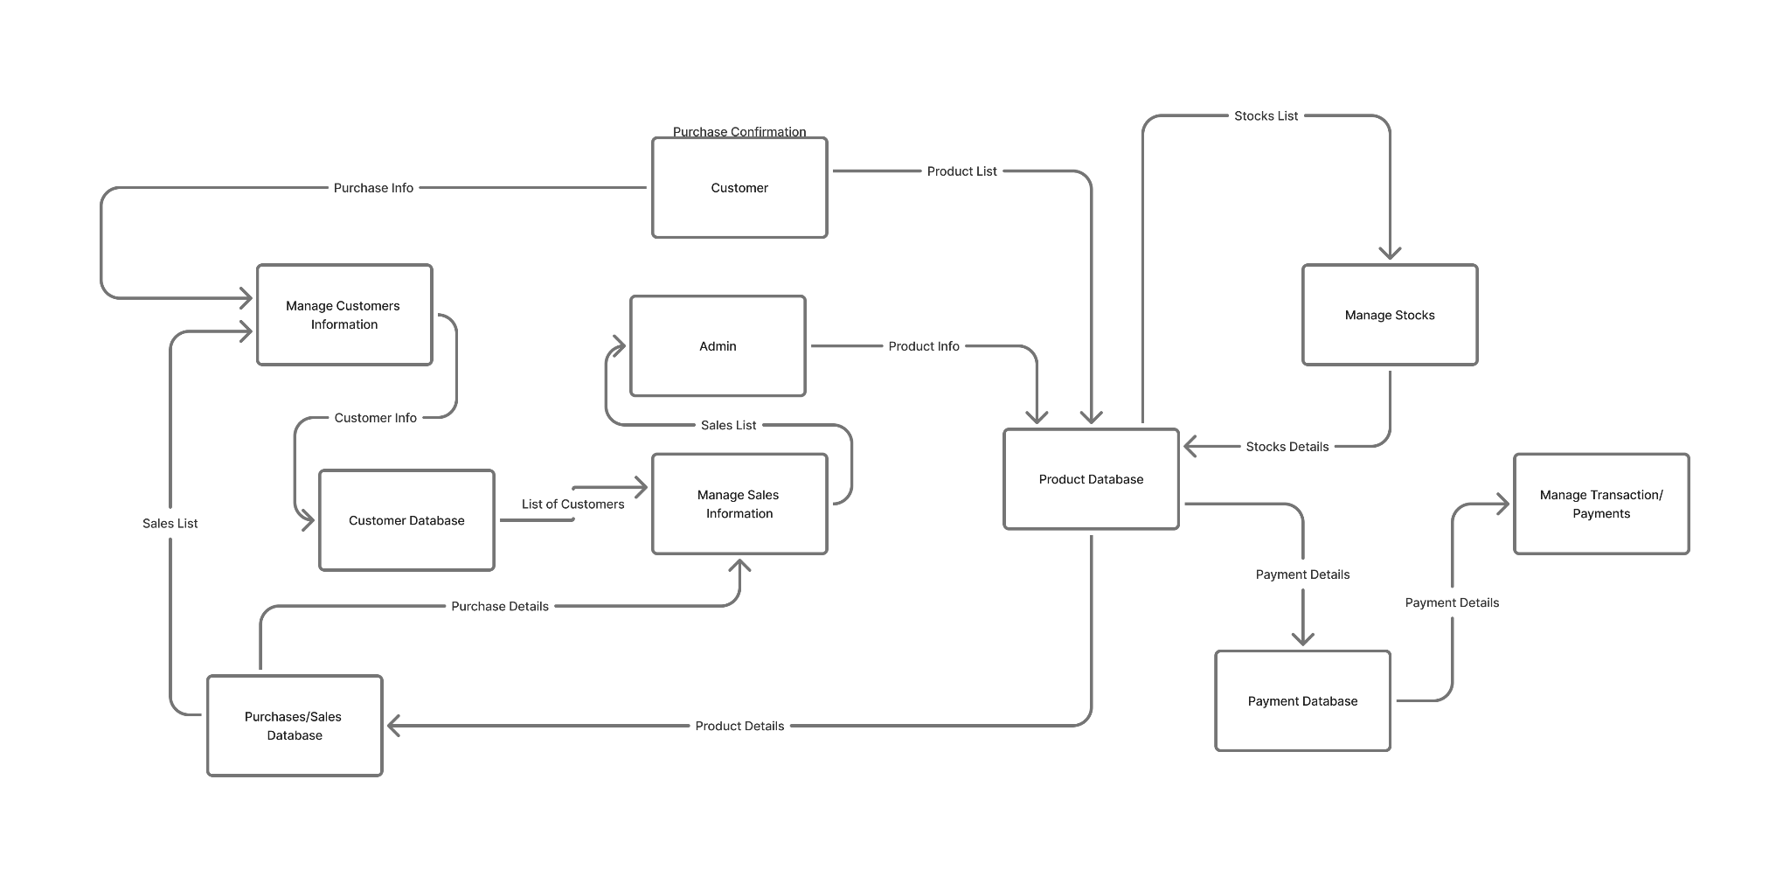

Entity Relationship Diagram (ERD)

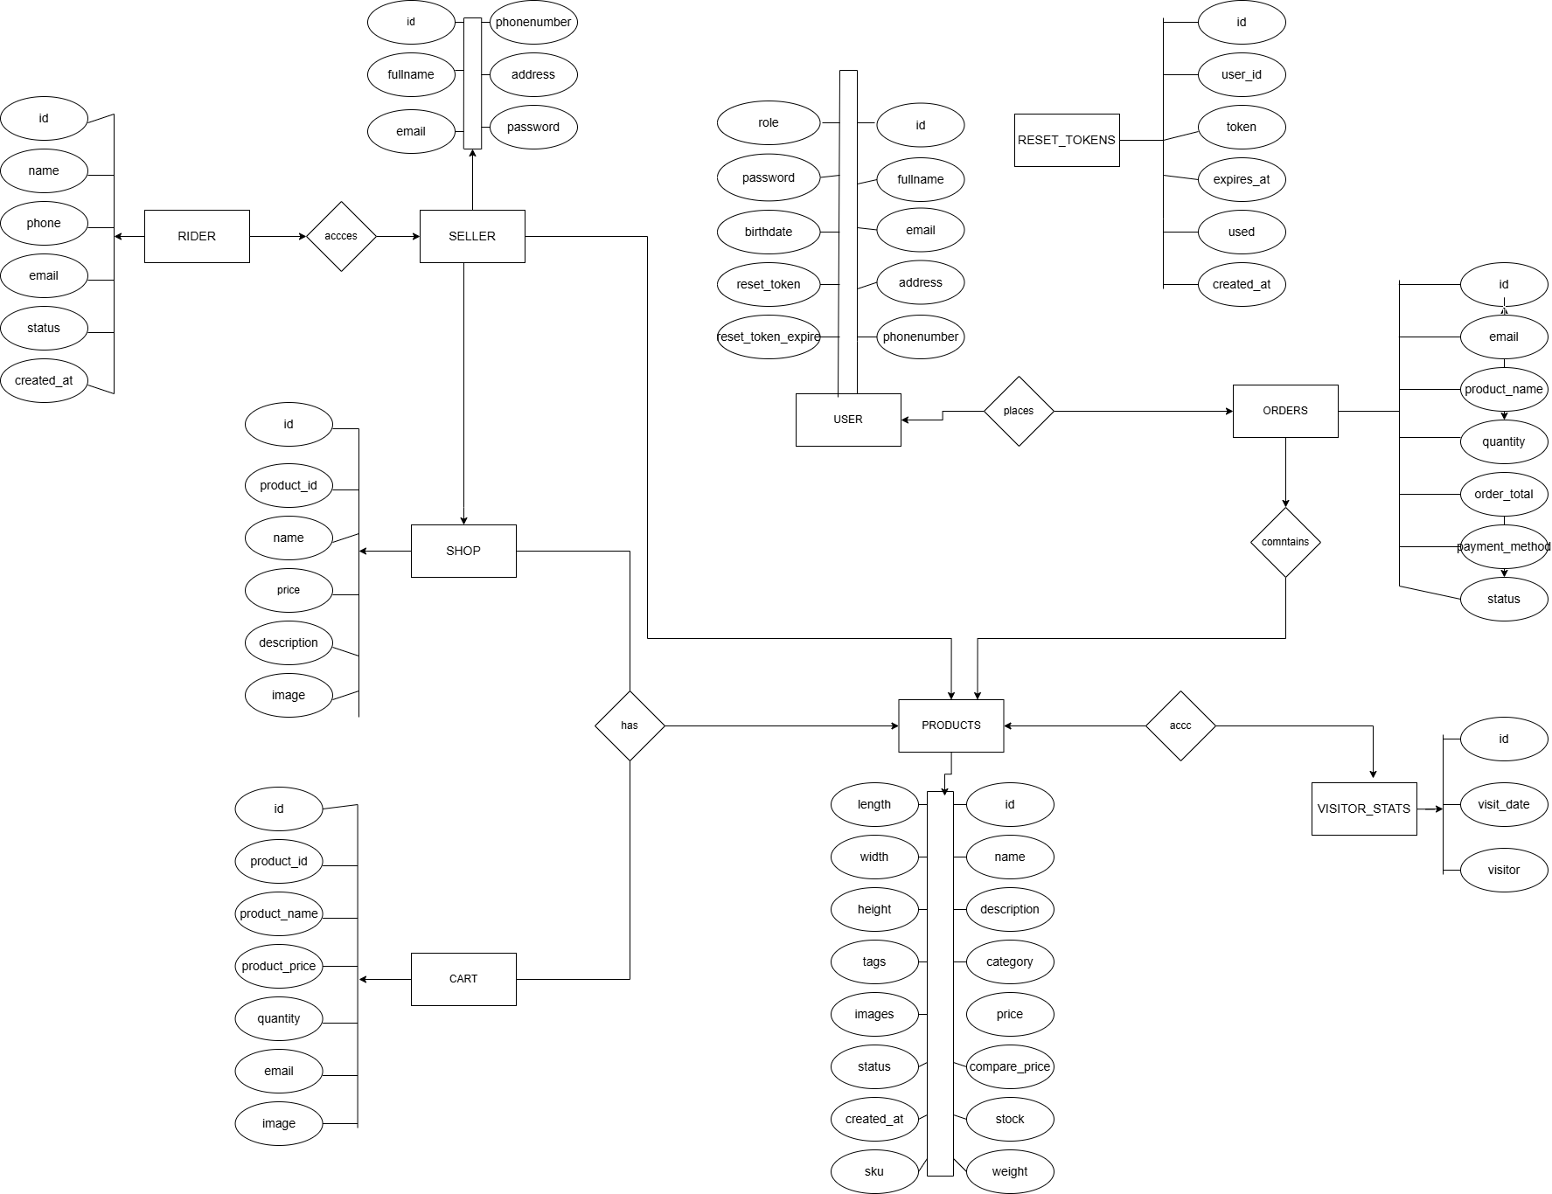

Chapter 4

Systems and Features
The proposed system is a single seller e-commerce website designed to sell ready-to-wear (RTW) products while integrating digital marketing strategies to attract and retain customers. The system’s main purpose is to provide an accessible, credible, and user friendly online shopping experience while analyzing how digital marketing impacts purchase behavior.
Major features of the system include:
- Home and Product Display Page
  - Presents all available RTW products with images, prices, sizes, and short descriptions.
  - The interface follows a clean and responsive design to ensure compatibility with desktop devices.
  - Products are arranged by category (e.g., tops, pants, dresses) for easy browsing.
- Ordering and Checkout System
  - Allows users to select items, add them to a shopping cart, and complete the purchase using available payment methods (Cash on Delivery.).
  - The system automatically calculates total cost including delivery fees and generates a unique order ID for tracking.

- Customer Registration and Login Module
  - Users can create personal accounts to save order history and monitor delivery status.
  - Customer data is secured with password encryption.
- Admin Dashboard
  - Enables the seller to manage products, monitor sales, track customer orders, and update product details.
  - Analytics such as top-selling items, and sales reports provide data for business insights.
- Search and Filtering Function
  - Allows customers to search for products by name, price, or size, improving user navigation and experience.
Result:
All system features were successfully developed and tested. Users were able to navigate the site easily, complete transactions, and leave reviews. The marketing integration tools effectively increased engagement and purchase intent during the testing phase.

Implementation Challenges
During the development and deployment of the RTW e-commerce website, several technical and operational challenges were encountered:
- Integration of Marketing Functions
  - Embedding promotional banners and linking social media accounts required proper API configuration and testing to ensure that real time updates reflect accurately on the website.
- User Interface Optimization
  - Ensuring a smooth and responsive design across devices (mobile, tablet, desktop) was time consuming. The layout had to be adjusted multiple times to maintain consistent image proportions and readability.
- Database Management
  - Managing multiple product categories, stock updates, and customer records led to database optimization challenges. Proper indexing and data validation were implemented to prevent redundancy and slow performance.
- Security Concerns
  - Protecting customer data such as login credentials and payment details was a priority. Implementing SSL encryption required additional configuration and testing.

- Payment Gateway and Checkout Process
  - Connecting online payment options such as GCash posed initial errors with API responses. The team mitigated this by testing transactions through sandbox environments before full deployment.
- Limited Testing Time
  - The testing period was restricted, limiting the amount of feedback collected from a wider user base. Despite this, initial results provided sufficient insight into user experience and functionality.
Result:
All identified challenges were addressed during the testing phase. Continuous debugging and user feedback led to improved stability and functionality of the final system.

User Feedback
Feedback was gathered from a selected group of respondents including potential customers, classmates, and instructors. Evaluation focused on usability, functionality, aesthetics, and overall satisfaction.

Table 1. Summary of User Feedback
Criteria | Description | Mean | Interpretation
Usability | Ease of navigation and accessibility | 4.6 | Very Satisfactory
Functionality | Reliability of features such as ordering and checkout | 4.5 | Very Satisfactory
Design and Layout | Visual appeal, clarity, and organization | 4.4 | Very Satisfactory
Responsiveness | System compatibility on different devices | 4.6 | Very Satisfactory
Marketing Features | Effectiveness of reviews, promos, and product ads | 4.5 | Very Satisfactory
Overall Satisfaction | General evaluation of the system | 4.6 | Very Satisfactory

Interpretation:
Respondents rated the system as very satisfactory across all criteria. They particularly appreciated the ease of ordering, organized layout, and promotional features that encouraged product interest.
Users also noted that customer reviews and product ratings helped them trust the seller more, validating the concept that digital marketing elements significantly influence purchasing behavior.

Comparison to Other Systems
To assess the competitive advantage of the developed system, it was compared with existing e-commerce platforms such as Shopee, Lazada, and Zalora.
Feature | Existing Platforms | Developed RTW System
Ownership | Multi-seller marketplace | Single seller platform
Target Market | General online consumers | Niche RTW fashion market
Product Management | Centralized seller tools | Seller-managed admin dashboard
Marketing Tools | Paid ads and vouchers | Built in social media promotion and discount management
Checkout System | Complex, multi-step | Simplified one page checkout
Customer Interaction | Limited to comments | Integrated review and feedback module
System Control | Platform-regulated | Full control by the seller

Discussion:
While larger platforms offer greater visibility, they often lack seller autonomy and customization. The developed system, being a single seller e-commerce website, allows full control of marketing, branding, and product management. This gives the seller flexibility to experiment with digital marketing strategies, improve brand identity, and directly manage customer relationships.
Furthermore, the simplicity of the ordering system and integrated digital marketing tools provide a more personalized and efficient shopping experience compared to existing multi seller marketplaces.

Summary
The system successfully achieved its objectives by integrating effective digital marketing techniques within a single seller RTW website. Through its user friendly interface, ordering system, and marketing features, it provides both functionality and credibility.
The user feedback confirmed the system’s usability, responsiveness, and marketing effectiveness, while implementation challenges strengthened the team’s technical skills and understanding of e-commerce development. Compared to existing systems, this project demonstrates an efficient and customizable solution tailored for small to medium-sized fashion sellers.

Chapter 5

Conclusion and Recommendations
This chapter presents the overall conclusion derived from the findings and user feedback gathered during the development and evaluation of the system entitled “The Effectiveness of Digital Marketing on Customer Purchase Decisions.” It also provides recommendations for future improvements and final thoughts regarding the system’s contribution to e-commerce development.

Conclusion
The study aimed to determine how digital marketing strategies can influence and enhance customer purchase decisions through a single seller RTW e-commerce website. The developed system successfully integrated key marketing elements product presentation, customer reviews, and usability into a fully functional online platform with an ordering system.
Based on the results and user feedback, the following conclusions were drawn:
- Digital marketing has a significant impact on consumer trust and purchasing behavior.
Users responded positively to product visibility, promotional offers, and the inclusion of customer reviews, which enhanced their confidence in buying RTW products online.
- The developed e-commerce system is effective and user friendly.
Users found the interface simple and intuitive, with clear navigation, responsive design, and smooth transaction flow from product selection to checkout.
- Promotional and marketing features improve engagement and sales conversion.
Features such as discount codes, vouchers, and free shipping incentives increased customer interest and purchase intent.
- The system provides a strong foundation for small-scale RTW sellers.
Compared to multi seller platforms, the single seller structure offers better control of product management, marketing campaigns, and brand presentation, allowing more direct engagement with customers.
In conclusion, the integration of digital marketing strategies within a well designed e-commerce website significantly improves customer trust, engagement, and buying decisions. The system effectively demonstrates how information technology can be used to support business growth and consumer satisfaction in the digital marketplace.

Recommendations
Based on the findings and evaluation, the following recommendations are proposed to enhance both the system and future related research:
- Enhance marketing automation.
Integrate advanced digital marketing tools such as email marketing, push notifications, and social media analytics to reach more customers and personalize promotions.
- Improve product personalization.
Implement product recommendation algorithms or “related items” features based on browsing behavior to increase customer retention and sales.
- Add customer analytics.
Include a reporting dashboard that tracks user behavior, product clicks, and conversion rates to help the seller make data driven marketing decisions.
- Expand payment options.
Provide more payment methods such as PayPal, credit/debit card integration, and installment payment services for customer convenience.
- Mobile Application Development.
Future improvements may include developing a mobile app version of the website for easier access and faster navigation on smartphones.
- Continuous System Maintenance and Updates.
Regular updates, testing, and user feedback should be implemented to ensure system security, accuracy, and usability.
- Further Study.
Researchers may extend this study to include larger sample sizes or different industries to analyze digital marketing effectiveness across various markets.

Final Thoughts
The project demonstrated how digital marketing and e-commerce can work hand-in-hand to influence consumer purchase behavior. By developing a single seller RTW website, the researchers proved that even small businesses can compete digitally through proper use of marketing strategies, customer engagement, and technology.
The team’s experience throughout the project emphasized the importance of innovation, collaboration, and adaptability in solving real world business problems. The system not only met the project’s objectives but also served as a learning platform that strengthened the group’s technical and analytical skills.
Ultimately, this project highlights that effective digital marketing is not only about promoting products but about building trust, enhancing user experience, and creating long-term customer relationships a principle that every modern business should adopt in the digital age.

Appendices
ScreenShots-Admin/seller side



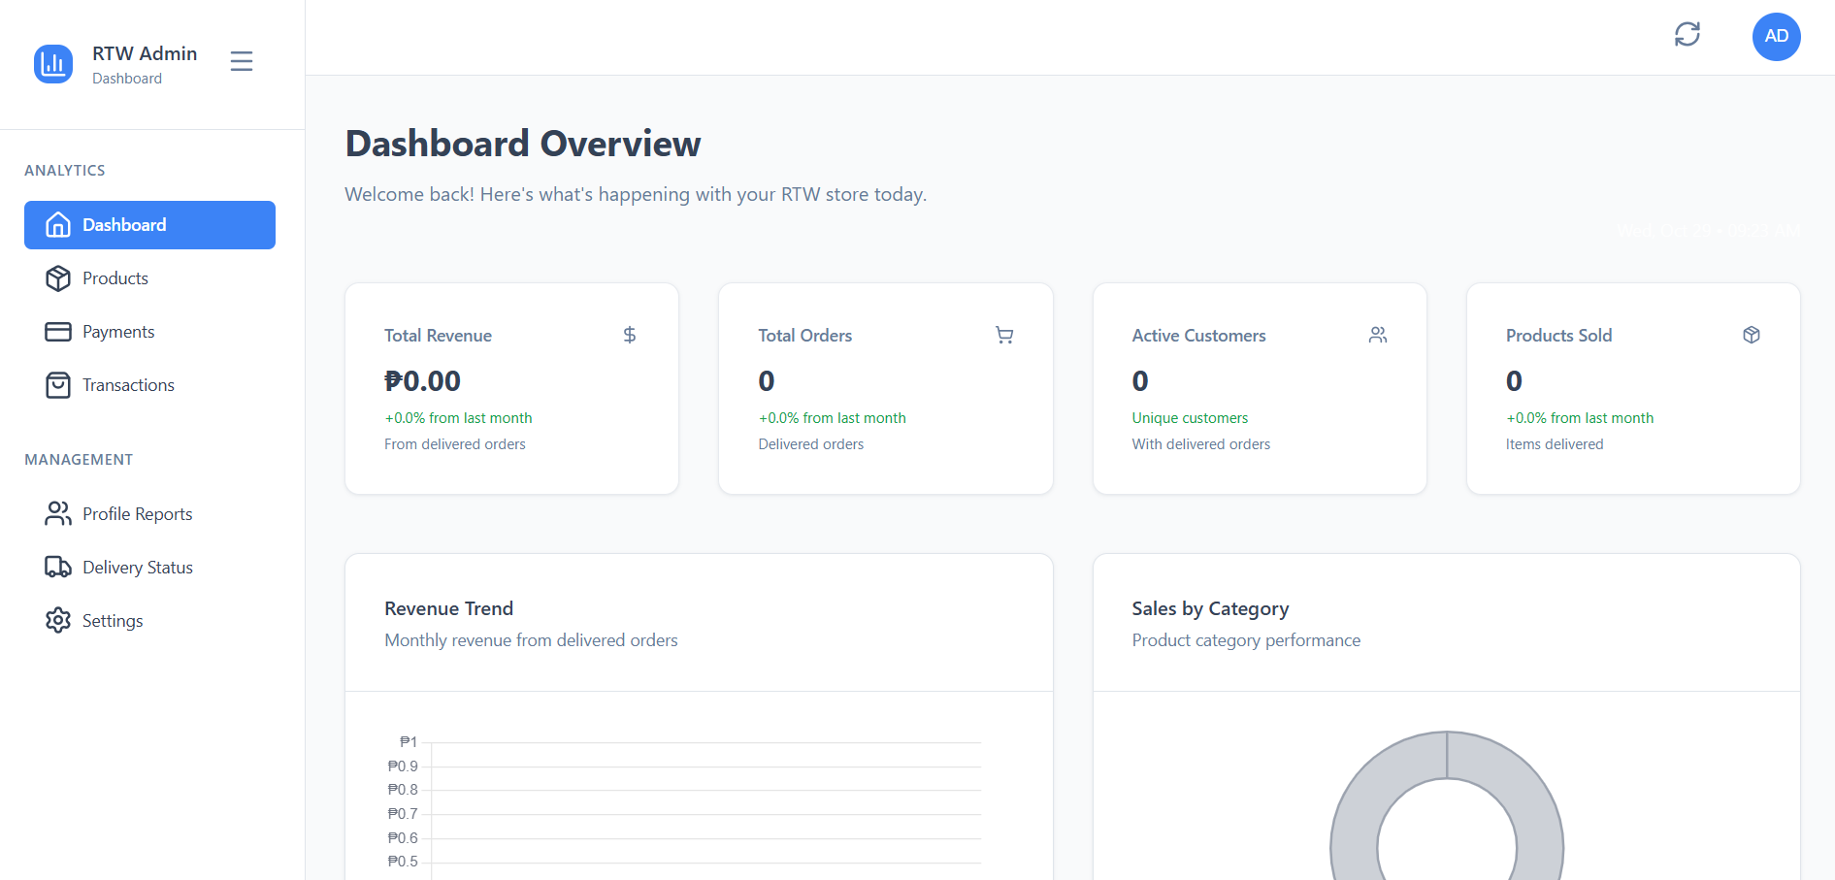

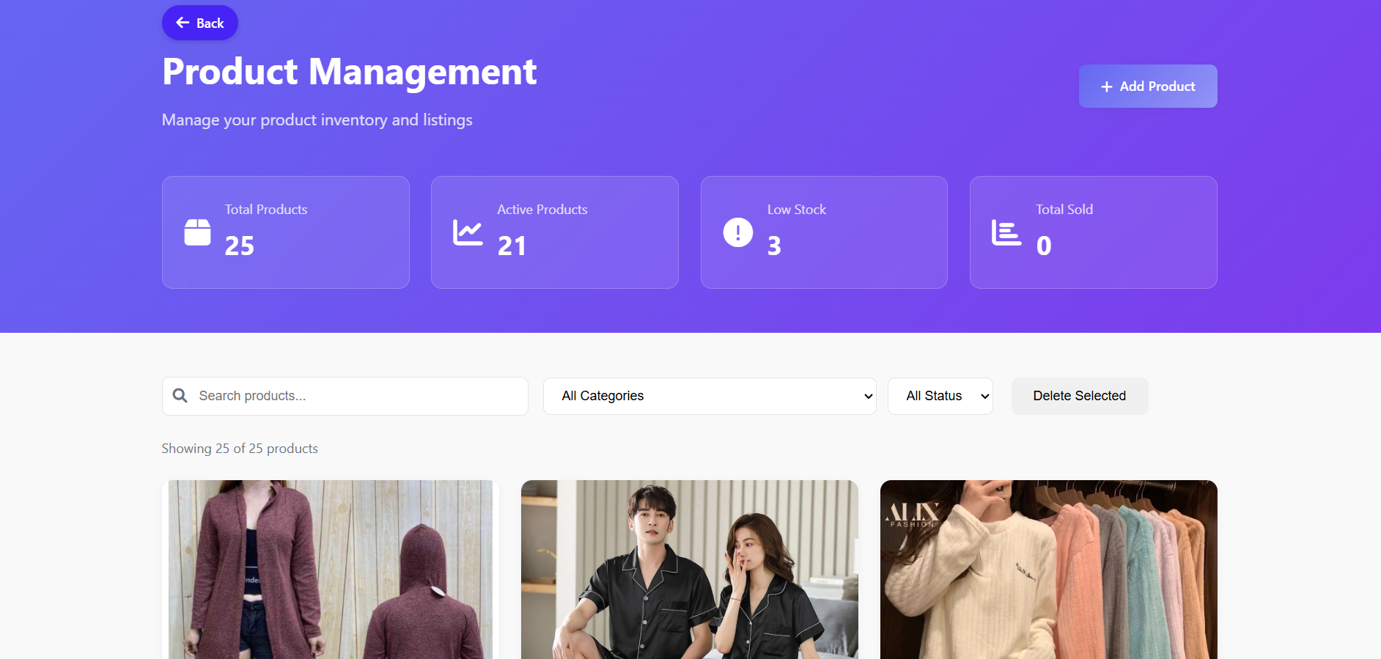

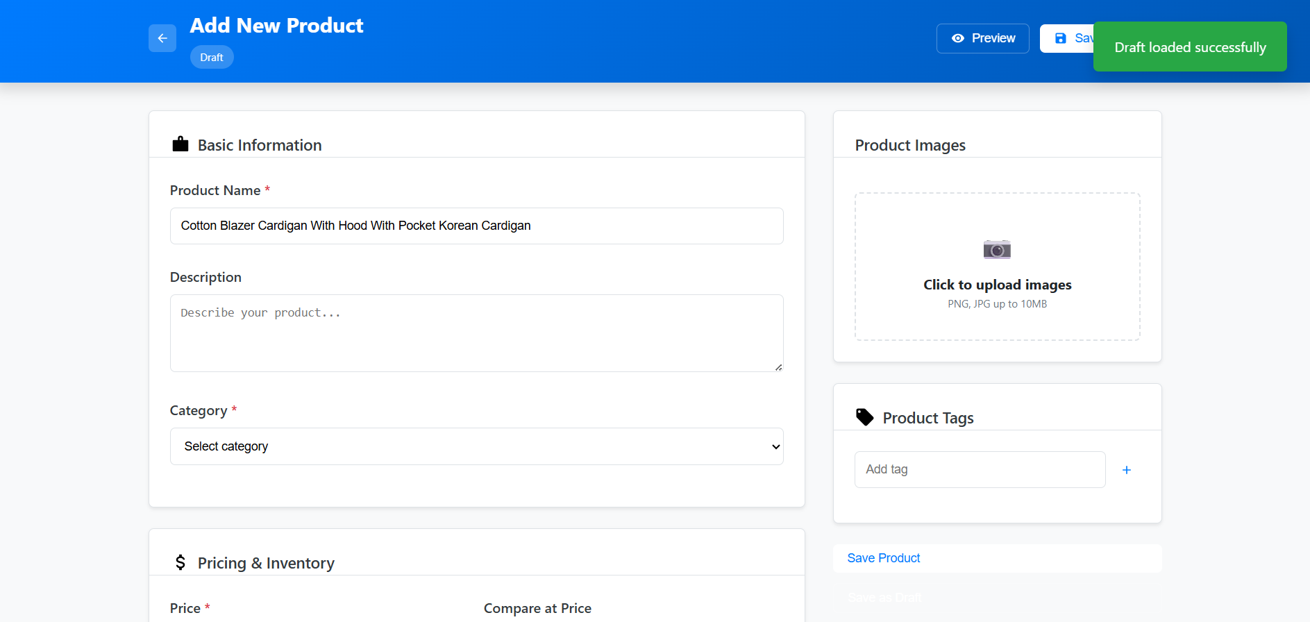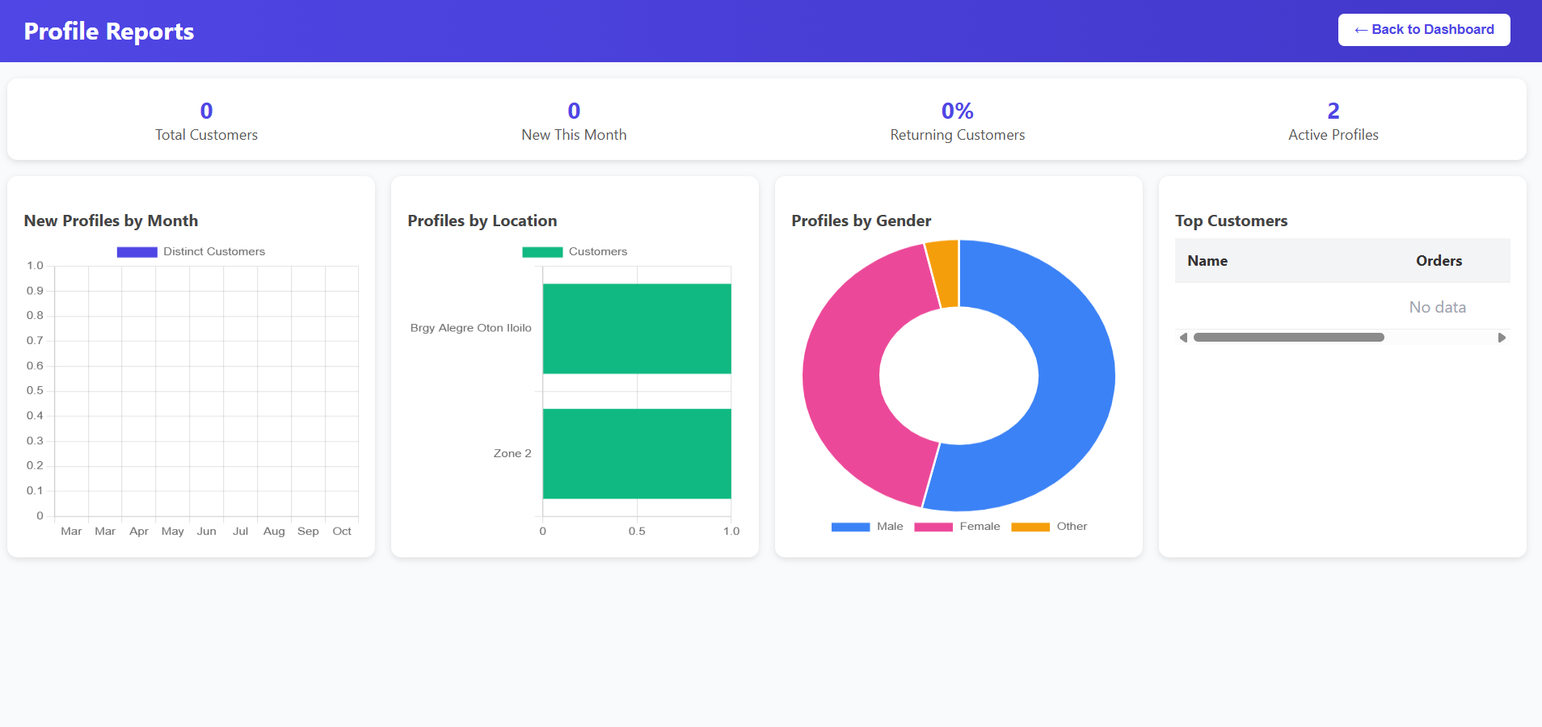
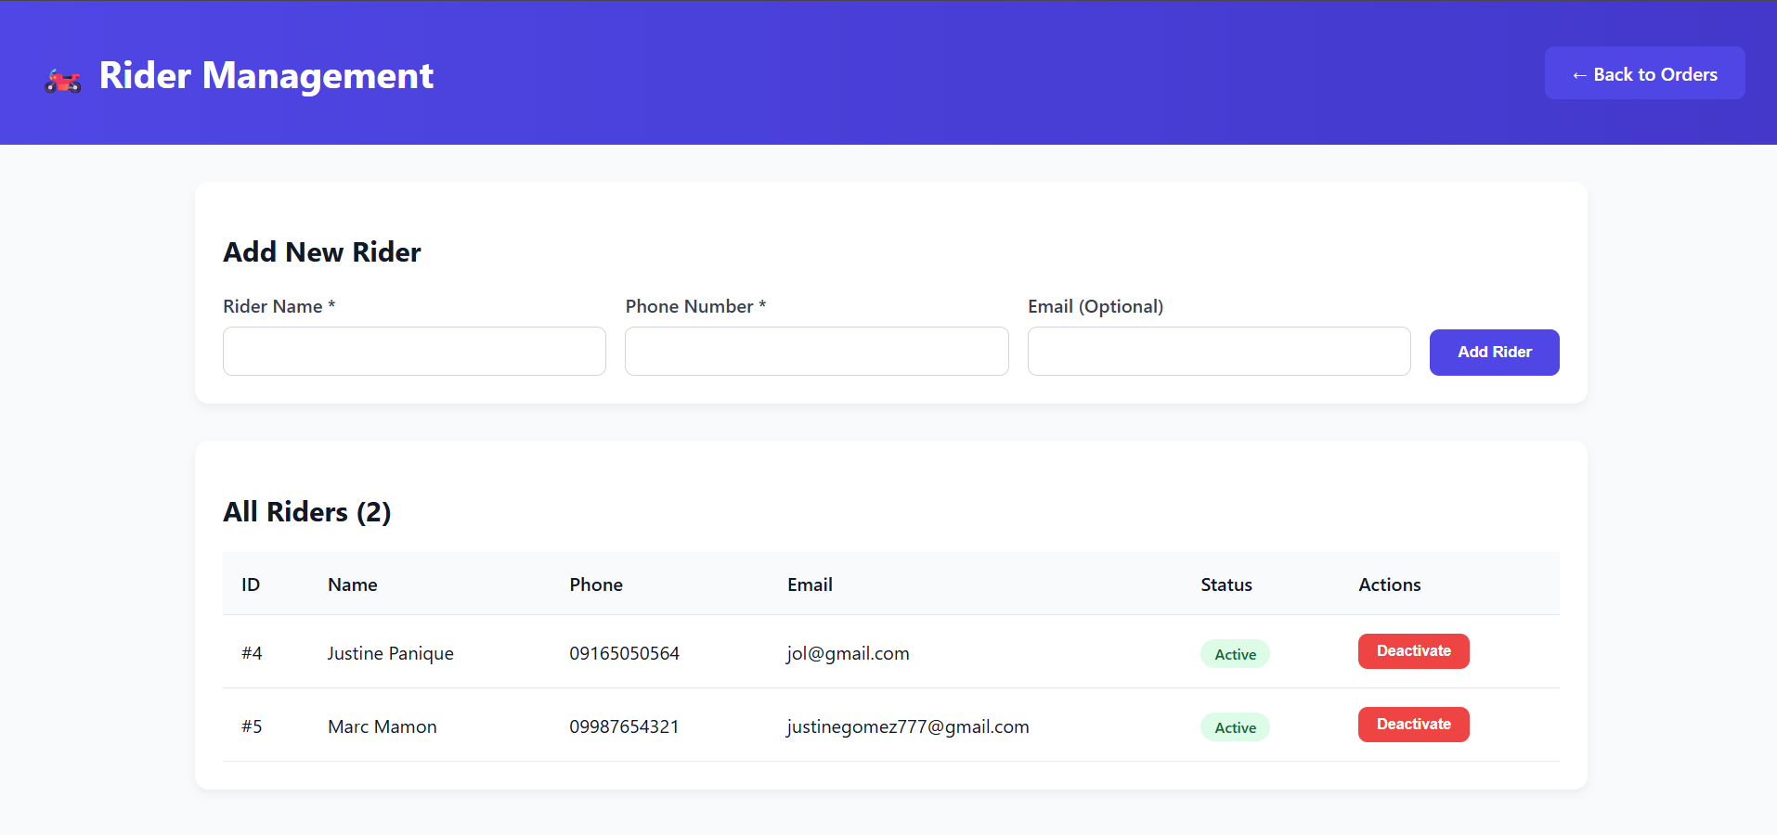

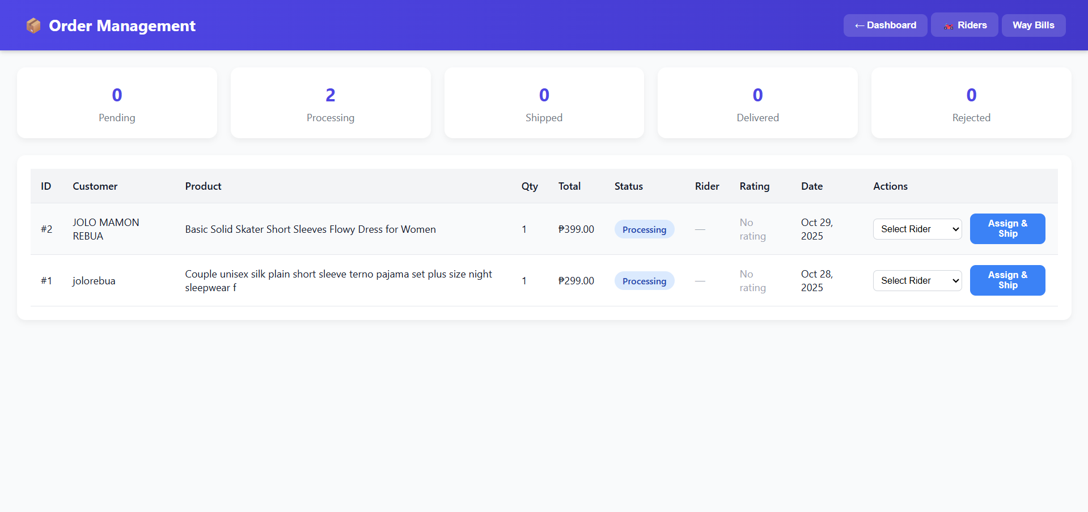
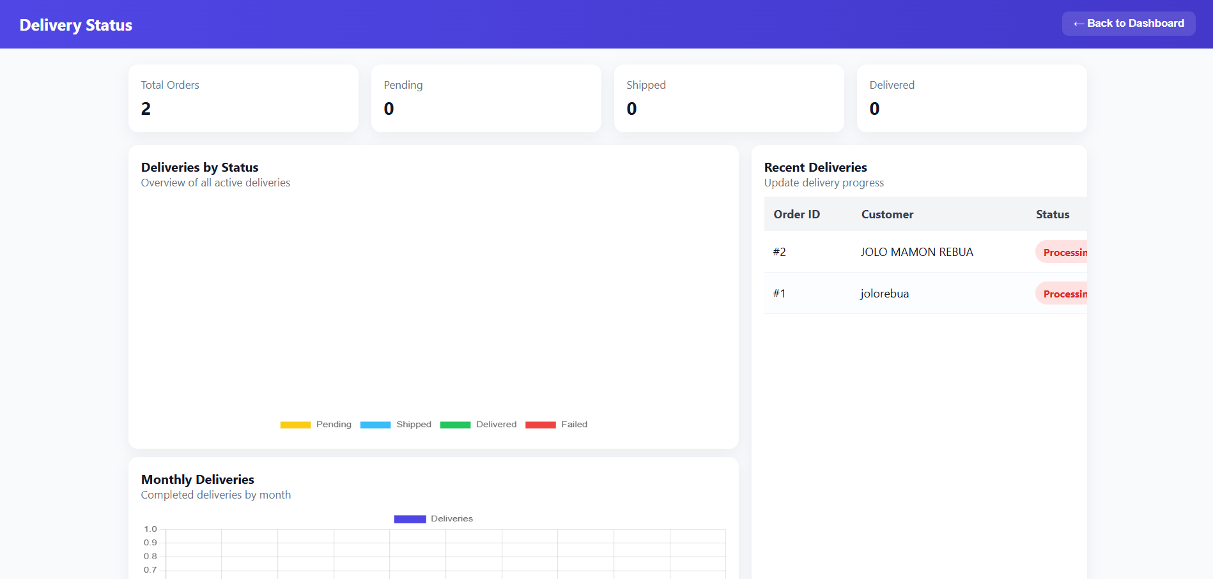



ScreenShot-Customer side




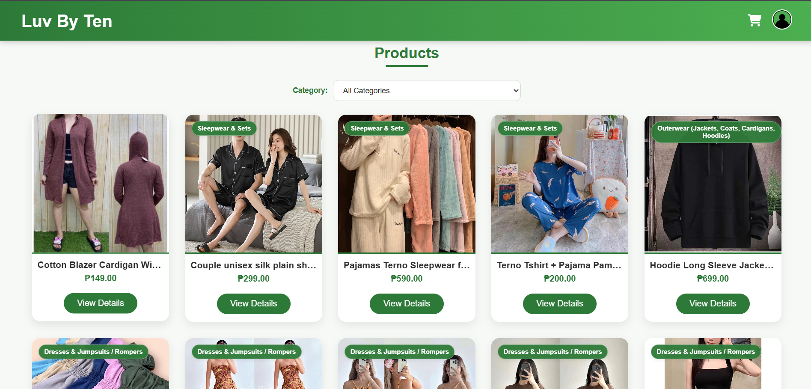
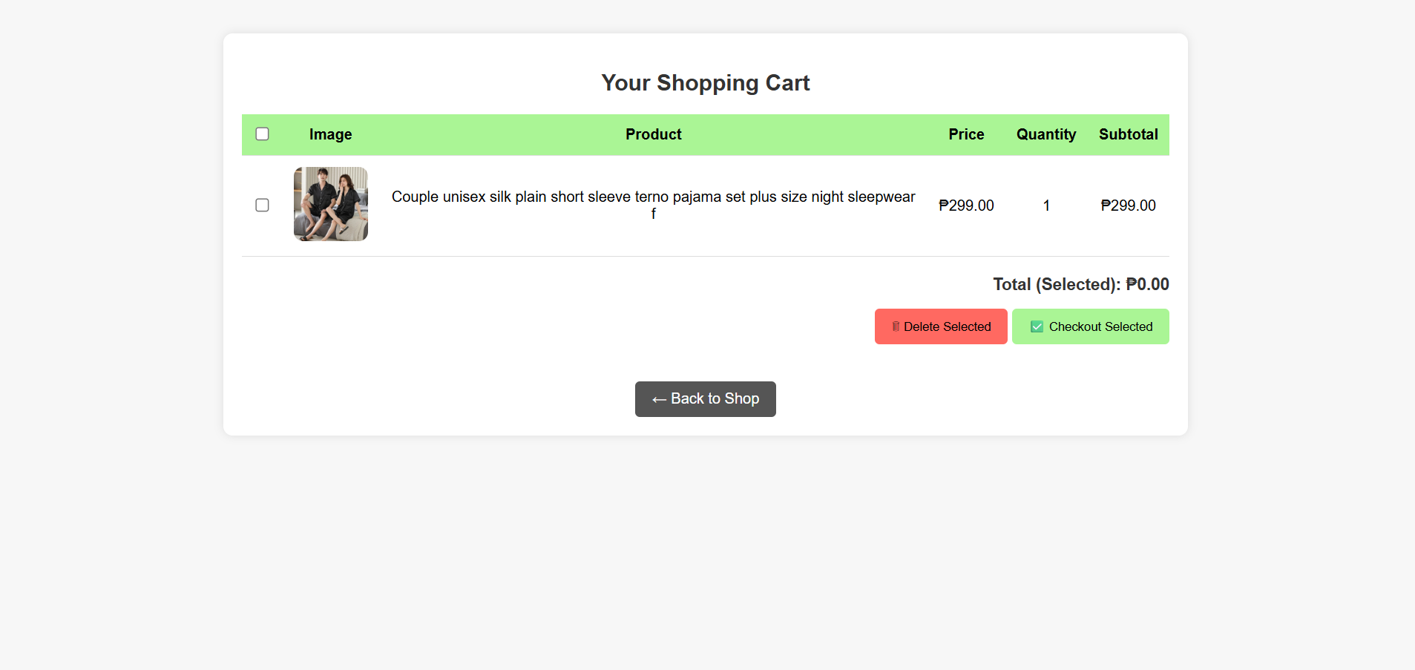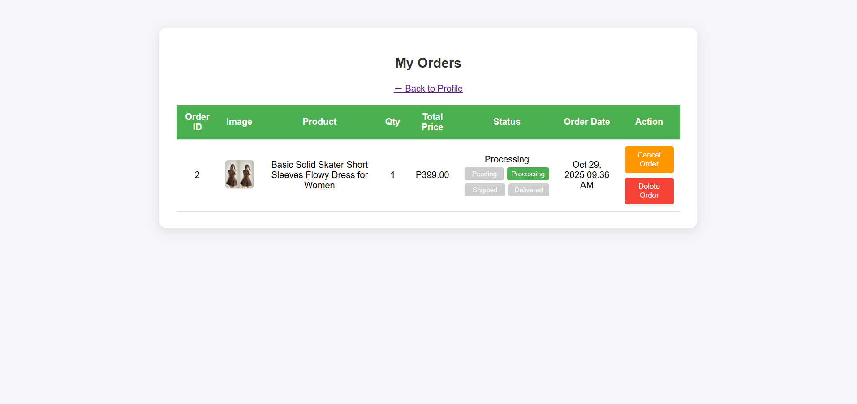

Curriculum vitae

Name: Marc Zidrick C. Montero
Address: Brgy. Sooc Arevalo, Iloilo City, Philippines
Contact Number: 09952063524
Email: brianmontero378@gmail.com

Personal Information
Date of Birth: July 21, 2003
Place of Birth: Iloilo City
Civil Status: Single
Nationality: Filipino
Languages: English, Filipino

Educational Background
Bachelor of Science and Information Technology
PHINMA University of the Iloilo - Iloilo City
2022 – 2026
Senior High School
Oton National High School, Iloilo City
2015 – 2020

Skills
● editor and encoder
● Time management and teamwork

Curriculum vitae
Name: Alejah Jane Opiala
Address: Benedicto, Jaro, Iloilo, Iloilo City
Contact Number: 09634483995
Email: alejahjaneopiala@gmail.com

Personal Information
Date of Birth: March 19, 2000
Place of Birth: Marilao, Bulacan
Civil Status: Single
Nationality: Filipino
Languages: English, Filipino

Educational Background
Bachelor of Science and Information Technology
PHINMA University of the Iloilo - Iloilo City
2022 – 2026
Senior High School
Roberto H. Tirol NHS - Concepcion Iloilo
2016 – 2021

Skills
● Programming
● Problem Solving

Curriculum vitae
Name: Jolo Rebua
Address: Alegre Oton, Iloilo
Contact Number: 09078594807
Email: Jolorebua25@gmail.com

Personal Information
Date of Birth: July 25, 2003
Place of Birth: Western Visayas Medical Center
Civil Status: Single
Nationality: Filipino
Languages: English, Filipino

Educational Background
Bachelor of Science in Information Technology
PHINMA University of Iloilo | 2022 - 2026

Junior Highschool - Senior Highschool
Strand OF TVL (ICT) Information and Communication Technology
Oton National High School | 2016 - April 2022

Skills
● Programming
● Problem Solving

